**Basic LINUX Commands – Lab 1**

1. Showing existing files & creating a new file

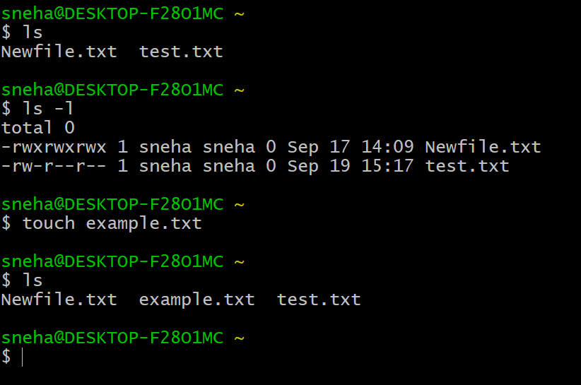

2. Changing modes in test.txt file using OCTAL method

Here, 774 => owner(rwx => 4+2+1 = 7), groups(rwx => 4+2+1 = 7), others(r = 4)

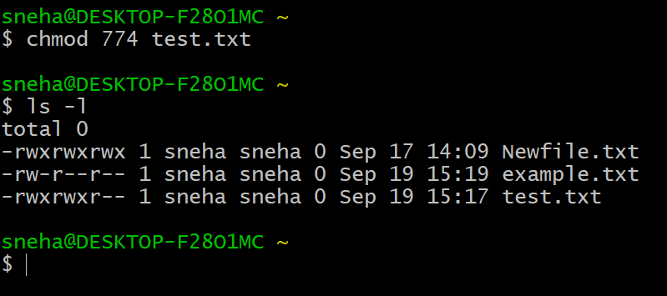

3. Changing modes in example.txt file using Symbolic method

Changing the groups permission in file to rwx by “g+wx” command

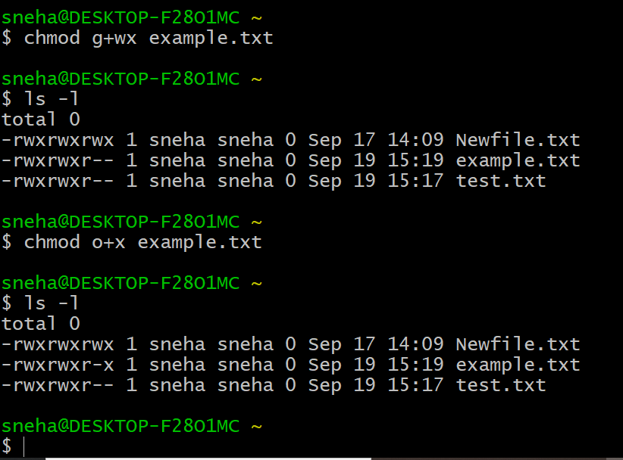

4. Removing access permission in test and example files using both methods.

For octal, changing the value to remove access

For symbolic, using ”-“ operator to remove access

